### PROGRAM REQUIREMENTS

* Commanding Officers must designate, in writing a Motorcycle Safety Representative (MSR).
* Ensure MSR is on the command check-in/check-out sheet.

### MSR RESPONSIBILITIES

* Obtain an ESAMS account and complete required ESAMS training.
* Directly responsible to the commander or commanding officer for proper execution of all aspects of the command motorcycle safety program.
* Establish a motorcycle mentorship program to promote rider education, safety, and training. Serve as the command motorcycle mentorship program coordinator.
* Identify all military personnel who operate or plan on operating a motorcycle, ensure 100 percent compliance with the training and PPE requirements.
* Provide the commander or commanding officer with a quarterly motorcycle safety training status report.
* Attend the quarterly regional, base or installation traffic and motorcycle safety council meetings.

### REFERENCES

DODI 6055.04, DoD Traffic Safety Program

<http://www.dtic.mil/whs/directives/corres/ins1.html>

OPNAVINST 5100.12J

Navy Traffic Safety Program

<http://doni.daps.dla.mil/allinstructions.aspx>

### NAVAL SAFETY CENTER

<http://www.safetycenter.navy.mil/>

ESAMS (Enterprise Safety Applications Management System) is the Navy’s motorcycle rider database. You can find motorcycle rider training compliance reports, by name, in ESAMS.

<https://www.hgwllc.com/Home/default.html>

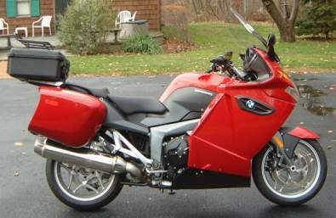

### Protective equipment REQUIREMENTS

* DOT approved helmet
* Impact resistant goggles, face-shield or

Wrap glasses

* Full fingered gloves
* Sturdy over the ankle footwear
* Long sleeve shirt below the elbows
* Long pants below the knees

**Motorcycle specific jackets and pants with armor are highly encouraged to provide ultimate crash protection!**

### SIGN UP FOR MOTORCYCLE TRAINING

<http://www.navymotorcyclerider.com/>

[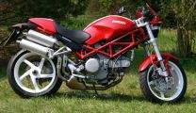](http://www.carsbase.com/photo/photo_full.php?id=30234)

# NSWC PowerPoint.gif

# Commander’s

**Motorcycle Guide**

**What You Need To Know!**

[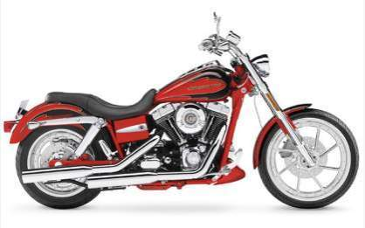](http://image.motorcyclistonline.com/f/newsandupdates/8741015/122_0706_38z+2007_harley_davidson_FXDSE_screamin_eagle_dyna+side.jpg)

### CO SUPPORT OPPORTUNITIES

* **Motorcycle Mentorship Meetings** are encouraged within the command and are available at most regional safety offices.
* **Command Organized Rides** are valuable to encourage positive peer pressure and informal program oversight.
* **Season Opening and Closing Fairs/Rides** are encouraged to provide an opportunity to inspect vehicles, check training, check licensing and discuss personal risk management.
* **Stand-Down Presentations**, **Data, and GMTs** are available on the National Safety Center web site and at many installation safety offices.

### BEST PRACTICES / KEYS TO SUCCESS

* Assign and support your Motorcycle Safety Representative (MSR)
* Include MSR on check-in/out routing – Keep Roster Current!
* Recommend all personnel complete a Pg13 stating they are aware of the reporting requirement if they ride or own a motorcycle (example available on the NSC Motorcycle web page)
* Engage Divisions and Chief’s Mess to know their riders and set the tone to support motorcycle training and mentoring opportunities
* Monitor Readiness Posture using ESAMS Reports provided by MSR
* Enforce training attendance and Motorcycle Rider Policy compliance
* Report training needs or inadequacies to the local supporting installation safety manager and command ISIC
* Encourage mentorship and personal risk management

### AVAILABLE TRAINING COURSES

CNIC Regions provide the following training:

* **LEVEL I: Basic Rider Course (BRC):** All riders are required to complete the BRC. This course provides novice riders the skills and knowledge needed to obtain a drivers license motorcycle endorsement. Loaner motorcycles are provided on a first come, first serve basis.
* **LEVEL II:** All riders must complete Level II training within 60 days of completing Level I training.

**BRC2:** This course is for non-sport bike riders to build upon the skills and knowledge that riders obtain in Level I courses.

**ADVANCE RIDER COURSE (ARC):** This course is designed for non-sport and sport bike riders to build upon the skills and knowledge that riders obtain in Level I courses.

**MILITARY SPORT BIKE RIDER COURSE (MSRC):** This course is intended solely for sport bike riders to build upon the skills and knowledge that riders obtain in Level I courses.

* **LEVEL III:** All riders are required to complete Level III training. This can be accomplished by completing any of the above training courses, or a Naval Safety Center Authorized Alternative Training. See NSC Website.

### PRE-PURCHASE COUNSELING

**Prior to purchasing a motorcycle, all Sailors are required to consult with the first Chief Petty Officer or officer in their chain of command to be certain they are aware of the responsibilities that come with ownership**.

### TRAINING REQUIREMENTS

* All Sailors who plan to purchase or operate a motorcycle (regardless of their intent to ride the motorcycle on or off base) are required to complete Level I training prior to operating.
* Additionally, operators of government-owned motorcycles shall complete Level I training prior to operating a government owned motorcycle.

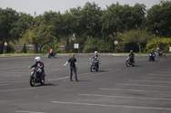

For information on open positions or to submit your resume, please visit our Web site at: www.lucernepublishing.com